***Title of Paper***

First Authora, Second Authorb and Third Authorc

aFirst Author Organization, City, Country, email; bSecond Author Organization, City, Country, email and cThird Author Organization, City, Country, email

Abstract

Abstract text

These instructions have been prepared in the format to be used for the drafting of the full text of the communications that have been accepted. The text of the abstract will have a maximum of 200 words. Senders must send the full text in a .doc file in accordance with these rules.

**Keywords:** type your keywords here, separated by commas

## Introduction

Here introduce the paper. The paragraphs continue from here and are only separated by headings, subheadings, images and formulae. The section headings are arranged by numbers, bold and 10 pt. Here follows further instructions for authors.

### Structure

Paper should contain from 4 to 8 pages. Figures and tables should be embedded and not supplied separately.

Please make sure that you use as much as possible normal fonts in your documents. Special fonts, such as fonts used in the Far East (Japanese, Chinese, Korean, etc.) may cause problems during processing. To avoid unnecessary errors you are strongly advised to use the ‘spellchecker’ function of MS Word. Follow this order when typing manuscripts: Title, Authors, Affiliations, Abstract, Keywords, Main text (including figures and tables), Acknowledgements, References. Collate acknowledgements in a separate section at the end of the article and do not include them on the title page, as a footnote to the title or otherwise.

Bulleted lists may be included and should look like this:

* first point;
* second point;
* and so on.

Please do not alter the formatting and style layouts which have been set up in this template document. As indicated in the template, papers should be prepared in single column format suitable for direct printing onto A4 paper size.

### Tables

All tables should be numbered with Arabic numerals. Every table should have a caption. Headings should be placed above tables, left justified. Only horizontal lines should be used within a table, to distinguish the column headings from the body of the table, and immediately above and below the table. Tables must be embedded into the text and not supplied separately. Below is an example which the authors may find useful.

Table 1. An example of a table.

|  |  |  |
| --- | --- | --- |
| An example of a column heading | Column A (*t*) | Column B (*t*) |
| And an entry | 1 | 2 |
| And another entry | 3 | 4 |
| And another entry | 5 | 6 |

### Construction of references

References must be listed at the end of the paper first alphabetically and then further sorted chronologically if necessary. Do not begin them on a new page unless this is absolutely necessary. Authors should ensure that every reference in the text appears in the list of references and vice versa. Indicate references by (Author_1, year) or (Author_1, year_1a, year_1b, year_2) or (Author_1 and Author_2, year) or (Author_1, year; Author_2, year) or (Author_1 et al., year) in the text.

Some examples of how your references should be listed are given at the end of this template in the ‘References’ section, which will allow you to assemble your reference list according to the correct format and font size.

### Section headings

Section headings should be left justified, bold, with the first letter capitalized and numbered consecutively, starting with the Introduction. Sub-section headings should be bold, with the first letter capitalized and numbered 1.1, 1.2, etc, and left justified, with second and subsequent lines indented. All headings should have a minimum of two text lines after them before a page or column break. Ensure the text area is not blank except for the last page.

### General guidelines for the preparation of your text

Scalar variable names should normally be expressed using italics. Weights and measures should be expressed in SI units. All non-standard abbreviations or symbols must be defined when first mentioned, or a glossary provided.

### File delivery

Submit PDF and the Copyright Form to the CHERNE 2025 Organizers using button “Call for Papers” at the Website: [CHERNE Workshop 2025](https://ocs.editorial.upv.es/index.php/CHERNE/CHERNE2025) .

### Footnotes

Footnotes should be avoided. Necessary footnotes should be denoted in the text by consecutive superscript letters1. The footnotes should be typed single spaced, and in smaller type size (8 pt), at the foot of the page in which they are mentioned, and separated from the main text by a one line space extending at the foot of the column.

Please do not change the margins of the template as this can result in the footnote falling outside printing range.

## Illustrations

All figures should be numbered with Arabic numerals (1, 2, 3,….). Every figure should have a caption. All photographs, schemas, graphs and diagrams are to be referred to as figures. Line drawings should be good quality scans or true electronic output. Low-quality scans are not acceptable. Figures must be embedded into the text and not supplied separately. Preferred format of figures are PNG, JPEG, GIF etc. Lettering and symbols should be clearly defined either in the caption or in a legend provided as part of the figure. Figures should be placed at the top or bottom of a page wherever possible, as close as possible to the first reference to them in the paper. Please ensure that all the figures are of 300 DPI resolutions as this will facilitate good output.

The figure number and caption should be typed below the illustration in 8 pt and centered. Artwork has no text along the side of it in the main body of the text. For example, see Figure 1.

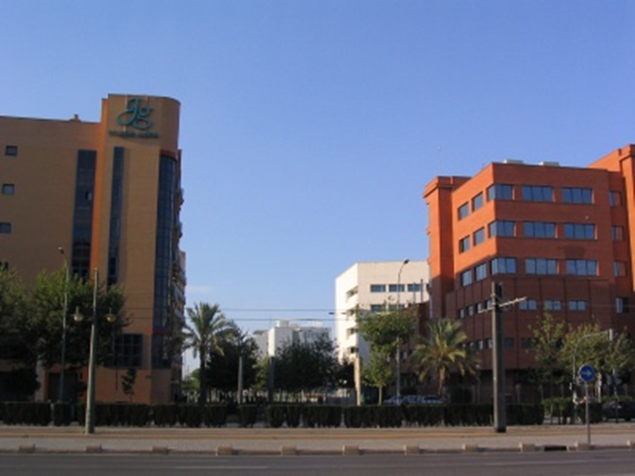

Fig. 1. first picture.

## Equations

Use italic letters, and number them consecutively with Arabic numerals in parentheses on the right hand side of the page (if referred to explicitly in the text).

$A={\left(\frac{B}{c+D}\right)}^{2}$ (1)

## License transfer

All authors are required to complete the CHERNE 2025 exclusive license transfer agreement before the papere can be published, which they can do online. This transfer agreement enables to protect the copyrighted material for the authors, but does not relinquish the authors’ proprietary rights. The copyright transfer covers the exclusive rights to reproduce and distribute the article, including reprints, photographic reproductions, microfilm or any other reproductions of similar nature and translations. Authors are responsible for obtaining from the copyright holder, the permission to reproduce any figures for which copyright exists.

**Acknowledgements**

Acknowledgements and Reference heading should be left justified, bold, with the first letter capitalized but have no numbers. Text below continues as normal.

**References**

Author_1, I., Author_2, I. year. Title of contribution. Title of Journal vol(issue), page-page.

Author_3, I. year. Title of book. Publisher, City.

Author_4, I. year. Title of chapter. Editor_1, I (Ed.), Title of book. Publisher, City, page-page.